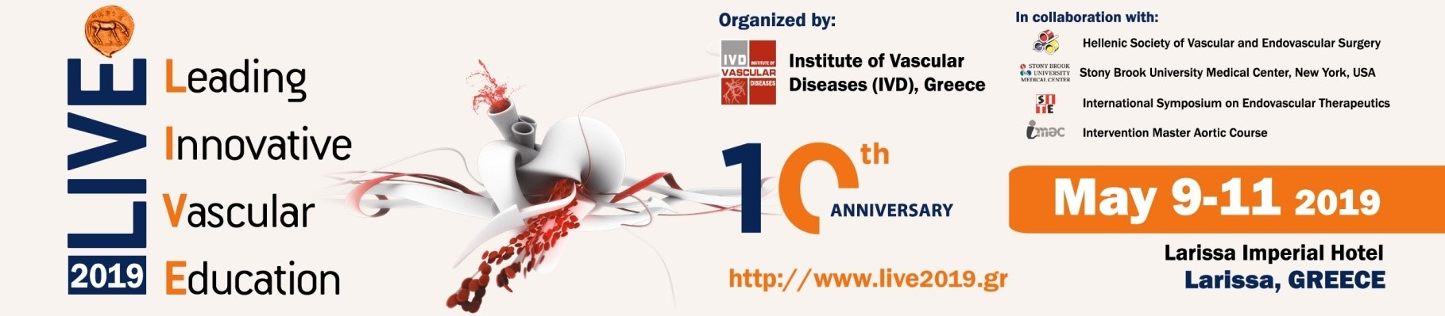

Registration Form
Please return the completed form to the Organizing-Administrative Bureau by  email (marilena@conferre.gr)  or fax (+30 26510 68611) | Administrative-Organizing Bureau/Secretariat:  CONFERRE SA:  Stavrou Niarchou Ave., Mares Position, Pedini  GR 455 00 Ioannina, GREECE  Tel.: +30-2651 0 68610, Fax: +30-2651 0 68611,  E-mail: info@conferre.gr, Website: www.conferre.gr

I. Contact Details
Surname: |  | Name:
Title/Position/Specialty:
Department/Hospital/
University/Institute etc:
Address:
City: |  | Country:
Telephone: |  | Ε-mail:

In the framework of the 10th anniversary of LIVE 2019 Symposium and for their continuous support during all these years, all announced “Collaborators” & “Partners in Success” are offered the benefit of five (5) FREE registrations for their members.
Requests will be treated on a first-come-first-served basis.
II. Registration – COLLABORATORS & PARTNERS IN SUCCESS*
Category | Cost
Please state the Society of which you are member. | FREE
Please state the Society of which you are member. | Society: ………………………………………………  Membership Number: ……………………………

*Detailed lists of the Societies offered the benefit of free registrations can be found
here: Collaborators and here: Partners in Success

Registration for members includes:
- Admission to the main Scientific Sessions
- Admission to the exhibition
- Symposium Material (badge, delegate bag, final programme, etc)
- Accredited Certificate of Attendance
- Opening Ceremony and Welcome Reception

DATE: ____/____/______ SIGNATURE:______________________________

